**Question 05:**

**Code**

#include<stdio.h>

void decideCarUsage(int carnumber, int day);

void main(void){

int carnumber,day;

carnumber=day=0;

printf("Enter the car number: \n");

scanf("%d",&carnumber);

printf("Enter the day of the week from 1-7: \n");

scanf("%d",&day);

decideCarUsage(carnumber, day);

}

void decideCarUsage(carnumber, day){

if (carnumber%2==0 && day%2==0){

printf("1\n");

}

else if (carnumber%2!=0 && day%2!=0)

printf("1\n");

else

printf("0\n");

}

**Output**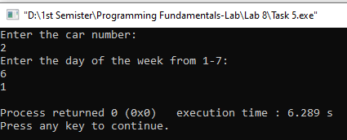

**Question 06:**

**Code**

#include<stdio.h>

void processArray(int sum, int minimum, int maximum, int size, int array[]);

void main(void){

int size,sum,maximum,minimum;

size=sum=0;

printf("Enter the size of the array: \n");

scanf("%d",&size);

int array[size];

printf("Enter the elements of the array: \n");

for (int i=0; i<size; i++){

scanf("%d",&array[i]);

}

maximum=array[0];

minimum=array[0];

processArray(sum, minimum, maximum, size, array);

}

void processArray(int sum, int minimum, int maximum, int size, int array[]){

for (int i=0; i<size; i++){

sum=sum+array[i];

}

printf("The sum of the elements of the array is: %d\n",sum);

for (int i=0; i<size; i++){

if (maximum<array[i]){

maximum=array[i];

}

}

printf("The maximum element in the array is: %d\n",maximum);

for (int i=0; i<size; i++){

if (minimum>array[i]){

minimum=array[i];

}

}

printf("The minimum element in the array is: %d\n",minimum);

}

**Output**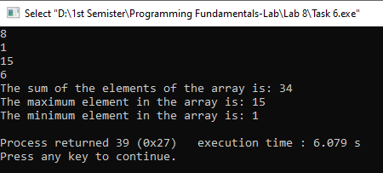

**Question 07:**

**Code**

#include<stdio.h>

void calculateDiscount(float totalpurchasedamount, int timevisited);

void main(void){

float totalpurchasedamount; int timevisited;

totalpurchasedamount=timevisited=0;

printf("Please enter the total purchase amount: \n");

scanf("%f",&totalpurchasedamount);

printf("Now enter the number of times you have visited in the past month: \n");

scanf("%d",&timevisited);

calculateDiscount(totalpurchasedamount, timevisited);

}

void calculateDiscount(float totalpurchasedamount, int timevisited){

if (timevisited>10 && totalpurchasedamount>=50){

totalpurchasedamount=totalpurchasedamount-totalpurchasedamount*0.15;

printf("The calculated discount amount is: %.2f\n",totalpurchasedamount);

}

else if (timevisited>5 && totalpurchasedamount>=30){

totalpurchasedamount=totalpurchasedamount-totalpurchasedamount*0.10;

printf("The calculated discount amount is: %.2f\n",totalpurchasedamount);

}

else{

printf("There is no discount applied and amount is: %.2f\n",totalpurchasedamount);

}

}

**Output**